SIMATS ENGINEERING (SAVEETHA SCHOOL OF ENGINEERING)
Department of Computer Science and Engineering

ASSESSMENT TOOL 2 – ARCHITECTURE / MODELING (SECURE INFRASTRUCTURE)

Course Code: | CSA5803 | Course Title: | DEVSECOPS ENGINEERING AND APPLICATION SECURITY
CO Assessed: | CO4 – Precision (BL1, BL2, BL3) | Assessment: | Assessment Tool 2
Weightage: | 30% of CIA | Total Marks: | 100
CO4 Statement: | Design secure DevSecOps infrastructure by developing architecture diagrams, modelling deployment workflows, Identity and Access Management (IAM) relationships, and GitOps workflows.
Student Name: | M.Kruthika Reddy | Reg. No.: | 192465037
Section Batch: | CSE-Cyber Security | Date:
Instructions to Students
• Design all architecture diagrams, deployment workflows, IAM relationships, and GitOps workflows originally and clearly.
• Use DiagrammeR or Draw.io for architecture modelling and maintain consistent labels, trust boundaries, data flows, and security controls.
• Clearly represent IAM roles/permissions, Infrastructure as Code (IaC), GitOps flow, and DevSecOps security integration wherever applicable.
• Include editable source files for diagrams, IaC/configuration files, methodology documentation, and all supporting project artifacts.
• Submit the GitHub repository link and final PDF report through Google Classroom before the specified deadline; verify that the repository is accessible and complete.

Question Type | Focus Area | Questions | Marks
ARCHITECTURE / MODELING | Design and Application Based | Q1 | Q1 – 100
GRAND TOTAL: |  | 100 Marks

Design Secure DevSecOps Infrastructure

1. Introduction
A secure DevSecOps infrastructure integrates development, security, operations, Identity and Access Management (IAM), Infrastructure as Code (IaC), CI/CD, and GitOps into one workflow.
The proposed architecture protects the application from the development stage until deployment and monitoring. Security checks are automatically performed during coding, building, testing, container creation, and deployment.
Main objectives
- Secure source code and Git repositories.
- Automatically test application security.
- Scan dependencies and container images.
- Use IAM with minimum required permissions.
- Manage infrastructure using IaC.
- Use GitOps for controlled deployment.
- Monitor deployed applications continuously.
- Maintain clear trust boundaries and data flows.

2. Proposed Secure DevSecOps Architecture
The architecture contains the following major components:
- Developer
- Git Repository
- CI/CD Pipeline
- SAST
- SCA
- Secret Scanning
- Unit Testing
- Container Build
- Container Image Scanner
- Container Registry
- Infrastructure as Code
- Terraform
- GitOps Repository
- Argo CD
- Kubernetes Cluster
- IAM
- Monitoring and Logging
- Security Operations
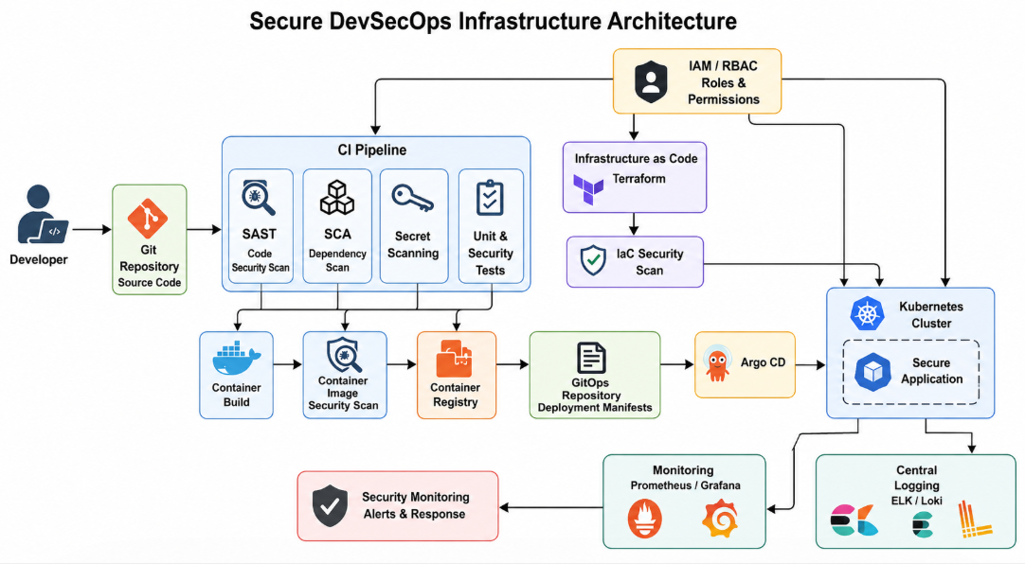Explanation
The developer first commits code to Git. The CI pipeline automatically performs:
- SAST
- SCA
- Secret scanning
- Unit testing
Only code that passes the required security checks continues to the container-building stage.
The container image is scanned before being stored in the container registry. Terraform manages infrastructure securely through IaC. Argo CD continuously compares the Kubernetes environment with the approved GitOps repository and deploys the required configuration.

3. Trust Boundaries
The architecture should clearly separate trusted and less-trusted areas.
Trust Boundary 1 – Developer Environment
Components:
- Developer workstation
- IDE
- Local source code
Security controls:
- Multi-factor authentication
- Endpoint protection
- Git authentication
- Secret scanning
Trust Boundary 2 – Source Control
Components:
- Git repository
- GitOps repository
Security controls:
- Branch protection
- Pull-request approval
- Signed commits
- Access control
- Audit logs
Trust Boundary 3 – CI/CD Environment
Components:
- CI runner
- SAST
- SCA
- Container scanner
Security controls:
- Temporary credentials
- Restricted permissions
- Isolated runners
- Security gates
Trust Boundary 4 – Production
Components:
- Kubernetes
- Application
- Database
- Services
Security controls:
- RBAC
- Network policies
- Secrets management
- Container security
- Runtime monitoring

4. Secure Deployment Workflow
The deployment workflow describes how code moves from the developer to production.
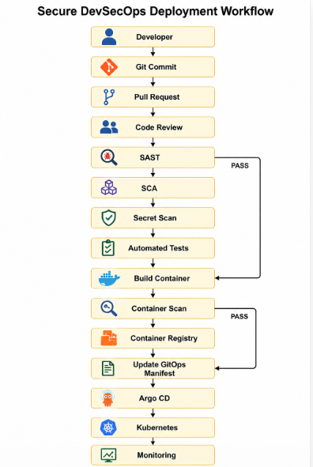
Deployment Process
Step 1 – Code Development
The developer writes application code and commits it to the Git repository.
Example 1: A developer creates a secure login API.
Example 2: A developer fixes an SQL injection vulnerability.
Step 2 – Pull Request
The developer creates a pull request instead of directly changing the production branch.
Step 3 – Code Review
Another authorized developer reviews the changes.
Step 4 – SAST
Static Application Security Testing checks the source code for vulnerabilities.
Examples:
- SQL injection
- Hard-coded credentials
- Unsafe functions
Step 5 – SCA
Software Composition Analysis checks third-party libraries.
Example:
Application
↓
Python Flask
↓
Third-party package
↓
Known vulnerability
If a critical vulnerable package is detected, the pipeline stops.
Step 6 – Secret Scanning
The pipeline searches for:
- API keys
- Passwords
- Tokens
- Cloud credentials
Step 7 – Testing
Automated unit and security tests are executed.
Step 8 – Container Build
The application is packaged into a container image.
Step 9 – Container Security Scan
The image is checked for vulnerable packages and unsafe configurations.
Step 10 – Container Registry
Only an approved image is pushed to the registry.
Step 11 – GitOps
The deployment manifest is stored in the GitOps repository.
Step 12 – Argo CD Deployment
Argo CD detects the approved configuration and synchronizes Kubernetes.
Step 13 – Monitoring
The deployed application is continuously monitored.

5. Identity and Access Management (IAM) Model
IAM controls who can access what and what actions they are allowed to perform.
IAM Relationship Diagram
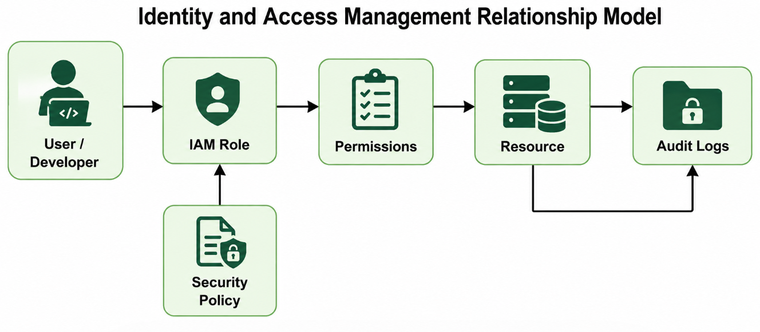IAM Structure
User
↓
Role
↓
Permission
↓
Resource
Example 1 – Developer
Developer
↓
Developer Role
↓
Read/Write Source Code
↓
Development Repository
The developer should not have production administrator access.
Example 2 – CI/CD Service Account
CI Service Account
↓
CI Role
↓
Build + Scan + Push Image
↓
Container Registry
The CI account should not have unrestricted Kubernetes administrator permissions.

6. IAM Roles
Role | Main Permissions
Developer | Read/write development code
Security Engineer | Security tools, reports and policies
CI Service Account | Build, test and push approved images
Argo CD | Deploy approved manifests
Kubernetes Admin | Cluster administration
Monitoring Account | Read monitoring data
Auditor | Read-only logs and reports
Principle of Least Privilege
Each identity should receive only the permissions required for its task.
Bad design:
CI Pipeline → Administrator → Entire Cloud Account
Better design:
CI Pipeline → CI Role → Container Registry

7. Infrastructure as Code (IaC)
Infrastructure should not be manually configured wherever possible.
Terraform can be used to define:
- Virtual networks
- Kubernetes clusters
- IAM roles
- Security groups
- Databases
- Storage
- Monitoring infrastructure
Example Terraform Structure
infrastructure/
│
├── main.tf
├── variables.tf
├── outputs.tf
├── providers.tf
├── iam.tf
├── network.tf
├── kubernetes.tf
└── security.tf
Simple Terraform Example
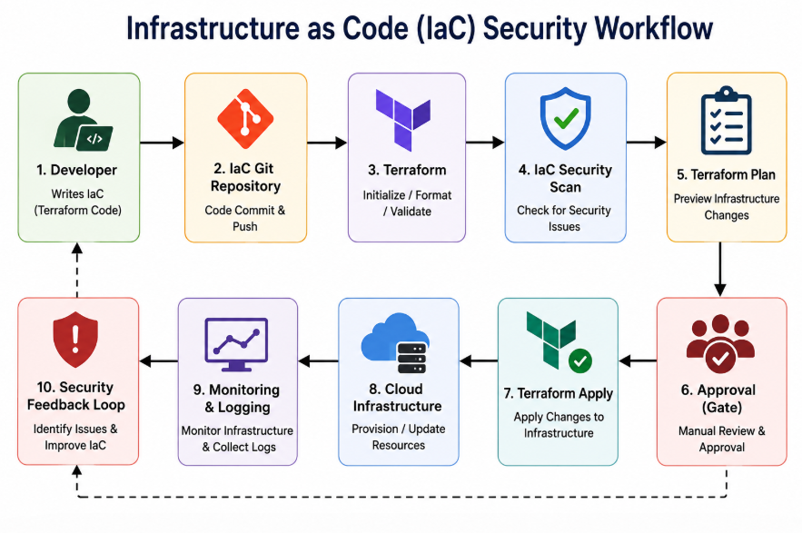
In a real deployment, additional controls should be applied such as encryption, access policies, logging and versioning.

8. IaC Security Workflow
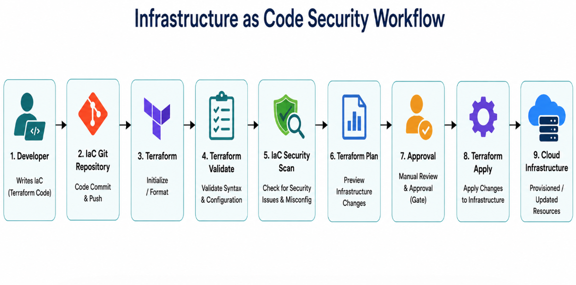Security checks
Before infrastructure is deployed:
- Validate Terraform syntax.
- Scan IaC configuration.
- Check IAM permissions.
- Check network configuration.
- Check encryption settings.
- Review Terraform plan.
- Obtain approval.
- Apply changes.

9. GitOps Workflow
GitOps uses Git as the source of truth for deployment configuration.
┌────────────┐
│ Developer │
└─────┬──────┘
↓
┌──────────────────────┐
│ Application │
│ Repository │
└─────┬────────────────┘
↓
┌──────────────────────┐
│ CI Security Pipeline │
└─────┬────────────────┘
↓
┌──────────────────────┐
│ Container Registry │
└─────┬────────────────┘
↓
┌──────────────────────┐
│ GitOps Repository │
└─────┬────────────────┘
↓
┌────────────┐
│ Argo CD │
└─────┬──────┘
↓
┌──────────────────────┐
│ Kubernetes Cluster │
└─────┬────────────────┘
↓
┌──────────────────────┐
│ Monitoring │
└─────┬────────────────┘
↓
┌──────────────────────┐
│ Security Feedback │
└─────┬────────────────┘
│
└──────────────→ Developer
GitOps Process
Developer
↓
Application Git
↓
CI Security Checks
↓
Container Registry
↓
GitOps Repository
↓
Argo CD
↓
Kubernetes
↓
Monitoring
↓
Security Feedback
Why GitOps is secure
GitOps provides:
- Version history
- Change tracking
- Pull-request review
- Easy rollback
- Controlled deployment
- Auditability
Example 1 – Normal deployment
A new approved application version is committed to the GitOps repository. Argo CD deploys it to Kubernetes.
Example 2 – Rollback
If version v2 causes a security or availability problem, the Git repository can be reverted to v1.

10. Kubernetes Security
The production Kubernetes environment should contain multiple security controls.
Kubernetes Cluster
|
+--------------+--------------+
| | |
Application API Server Monitoring
|
Container
|
Network Policy
|
Secrets
|
RBAC
Important controls
- Kubernetes RBAC
- Network policies
- Namespace isolation
- Container image scanning
- Non-root containers
- Resource limits
- Secrets management
- Pod security controls
- Audit logging
- Runtime monitoring

11. Monitoring and Security Response
Monitoring is required after deployment.
Monitoring architecture
Application
↓
Metrics ─────→ Prometheus
↓ ↓
Logs ───────→ Log System
↓
Grafana
↓
Security Alerts
↓
Security Team
Monitoring should identify:
- Failed login attempts
- Unusual network traffic
- Container failures
- Unauthorized access
- CPU/memory anomalies
- Suspicious API activity
- Configuration changes

12. Security Gates
Security gates prevent unsafe code from reaching production.
Stage | Security Gate
Source Code | Secret scanning
Pull Request | Code review
Build | SAST
Dependency | SCA
Container | Image scanning
Infrastructure | IaC scanning
Deployment | Approval/GitOps
Runtime | Monitoring
Production | Security alerts
Example
If SAST detects a critical vulnerability:
Code
↓
SAST
↓
Critical vulnerability
↓
PIPELINE STOPPED
↓
Developer fixes issue
↓
New Pull Request
This is better than deploying first and discovering the vulnerability later.

13. Secure DevSecOps End-to-End Workflow
DEVELOPER
|
↓
SOURCE CONTROL
|
↓
PULL REQUEST
|
↓
CODE REVIEW
|
↓
+------------+------------+
| | |
SAST SCA SECRET SCAN
| | |
+------------+------------+
|
↓
AUTOMATED TESTS
|
↓
CONTAINER BUILD
|
↓
IMAGE SECURITY SCAN
|
↓
CONTAINER REGISTRY
|
↓
GITOPS REPOSITORY
|
↓
ARGO CD
|
↓
KUBERNETES CLUSTER
|
↓
APPLICATION
|
+-------+-------+
| |
↓ ↓
MONITORING LOGGING
| |
+-------+-------+
↓
SECURITY ALERT
|
↓
SECURITY RESPONSE

14. Security Controls Mapping
Security Area | Control
Identity | IAM + MFA
Source Code | Branch protection
Code | SAST
Dependencies | SCA
Credentials | Secret scanning
Container | Image scanning
Infrastructure | Terraform + IaC scanning
Deployment | GitOps
Kubernetes | RBAC + Network Policies
Secrets | Secrets Manager
Monitoring | Prometheus/Grafana
Logging | Centralized logging
Incident Response | Alerts and response workflow

15. Repository Structure
The GitHub repository should contain editable source files and supporting documentation.
secure-devsecops-infrastructure/
│
├── README.md
│
├── architecture/
│ ├── architecture.R
│ ├── deployment-workflow.R
│ ├── iam-model.R
│ ├── gitops-workflow.R
│ └── diagrams/
│
├── application/
│ ├── src/
│ ├── tests/
│ └── Dockerfile
│
├── infrastructure/
│ ├── main.tf
│ ├── variables.tf
│ ├── outputs.tf
│ ├── iam.tf
│ ├── network.tf
│ └── security.tf
│
├── kubernetes/
│ ├── deployment.yaml
│ ├── service.yaml
│ ├── namespace.yaml
│ └── network-policy.yaml
│
├── gitops/
│ ├── application.yaml
│ └── deployment.yaml
│
├── security/
│ ├── sast/
│ ├── sca/
│ ├── iac-scan/
│ └── container-scan/
│
├── monitoring/
│ ├── prometheus/
│ └── grafana/
│
└── documentation/
├── methodology.md
├── security-controls.md
└── deployment-guide.md

16. Methodology
The project can be implemented using the following methodology:
Phase 1 – Requirement Analysis
Identify:
- Application requirements
- Infrastructure requirements
- Security requirements
- User roles
- Deployment requirements
Phase 2 – Architecture Design
Design:
- DevSecOps architecture
- Trust boundaries
- Data flows
- IAM relationships
- Deployment workflow
Phase 3 – IaC Development
Create Terraform files for:
- Infrastructure
- IAM
- Network
- Security controls
Phase 4 – Security Integration
Integrate:
- SAST
- SCA
- Secret scanning
- IaC scanning
- Container scanning
Phase 5 – GitOps
Create:
- GitOps repository
- Kubernetes manifests
- Argo CD configuration
Phase 6 – Monitoring
Configure:
- Metrics
- Logs
- Alerts
- Security monitoring
Phase 7 – Validation
Test:
- Unauthorized access
- Vulnerable code
- Vulnerable dependencies
- Invalid IAM permissions
- Unsafe infrastructure
- Failed deployments

17. Security Verification
The architecture should be tested using security scenarios.
Test Case 1 – Hard-coded password
Developer commits password
↓
Secret Scanner
↓
Secret detected
↓
Pipeline fails
Expected result: Deployment must be blocked.
Test Case 2 – Vulnerable dependency
Developer adds vulnerable library
↓
SCA Scanner
↓
Critical vulnerability detected
↓
Pipeline fails
Expected result: Developer must replace or update the dependency.
Test Case 3 – Unauthorized deployment
Unauthorized User
↓
IAM Check
↓
Permission Denied
↓
Deployment blocked
Expected result: Unauthorized users cannot deploy to production.

18. Benefits of the Proposed Architecture
- Security is integrated throughout development.
- Automated security testing reduces human mistakes.
- IAM limits unauthorized access.
- IaC provides repeatable infrastructure.
- GitOps provides controlled deployments.
- Kubernetes provides scalable application deployment.
- Monitoring detects suspicious activity.
- Git history provides traceability.
- Rollback becomes easier.
- Security problems can be detected earlier.

19. Conclusion
The proposed Secure DevSecOps infrastructure combines DevSecOps, IAM, IaC, CI/CD, GitOps, Kubernetes, and continuous monitoring into one secure architecture.
The main security principle is "security at every stage" rather than checking security only after deployment.
The complete workflow is:
Code
↓
Review
↓
SAST + SCA + Secret Scan
↓
Testing
↓
Container Scan
↓
Registry
↓
GitOps
↓
Argo CD
↓
Kubernetes
↓
Monitoring
↓
Security Response
This architecture satisfies the required areas of architecture modelling, deployment workflow, IAM relationship modelling, IaC, GitOps workflow, security integration, trust boundaries, data flows, and continuous monitoring.
Final submission checklist
- Architecture diagram created using DiagrammeR/Draw.io
- Deployment workflow diagram included
- IAM relationship diagram included
- GitOps workflow diagram included
- Trust boundaries identified
- Security controls identified
- IaC files included
- Kubernetes configuration included
- GitHub repository created
- Editable diagram source files included
- Methodology documentation included
- Screenshots/evidence added
- Final PDF report prepared
- GitHub repository link verified before submission

RUBRICS FOR CALCULATION

Criteria | Wt. | Level 4 – Exemplary | Level 3 – Proficient | Level 2 – Developing | Level 1 – Beginning
IAM Model and Access Control Design | 20% | Designs a comprehensive IAM model with clearly defined identities, roles, permissions, authentication and least-privilege access controls | Designs an appropriate IAM model with most roles and access controls correctly represented and only minor gaps | Provides a basic IAM model with limited role definition, permissions or access-control details | Provides an incomplete or inaccurate IAM model with weak or inappropriate access controls
Infrastructure as Code (IaC) Modelling | 30% | Accurately models infrastructure provisioning through IaC with reusable, consistent and secure configuration components | Models IaC workflow correctly with appropriate configuration structure and only minor omissions | Provides a basic IaC model with limited automation, structure or security considerations | Provides an incomplete or incorrect IaC model with poor configuration and automation representation
GitOps Workflow and Version Control | 20% | Clearly models a complete GitOps workflow including repository changes, review, automated synchronization, deployment and desired-state management | Models the GitOps workflow correctly with most stages represented and minor workflow gaps | Provides a basic GitOps workflow with missing stages or unclear repository-to-deployment relationships | Provides an incomplete or inaccurate GitOps workflow with weak version-control integration
Security Integration and Workflow Automation | 20% | Effectively integrates IAM, IaC and GitOps with security validation, approvals, automation and auditable workflow controls | Integrates appropriate security and automation controls with only minor gaps | Shows basic security integration and automation but several controls or workflow relationships are missing | Shows limited or incorrect integration of security controls and workflow automation
Documentation and Workflow Clarity | 10% | Clearly documents IAM, IaC and GitOps components and presents the complete workflow with strong technical justification | Provides clear documentation and workflow explanation with minor clarity or justification gaps | Provides basic documentation with limited explanation of workflow components and relationships | Provides incomplete or unclear documentation with little technical justification

Rubrics:
Criteria | Weightage | Q5 (10) | Total  Marks  (50)
IAM Model and Access Control Design | 25%
Infrastructure as Code (IaC) Modelling | 30%
GitOps Workflow and Version Control | 20%
Security Integration and Workflow Automation | 15%
Documentation and Workflow Clarity | 10%
Total per Question | 100 Marks

────
100

